Spark Scala job for cleansing

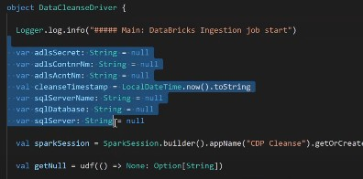

In this Spark Scala job we have a object created and whatever action performed in this is almost similar to the data ingestion . In the above code we are describing different parameters and arguments are passed for creating the spark session environment and then we are connecting to sql by passing servername ,Database and all those server details.

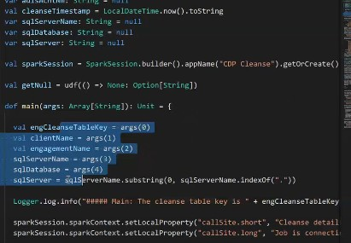

So once we are done with the connection,we need to create a container

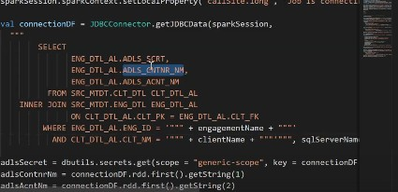

After the container creation We need to enable the active flag and set to true as dataingestion

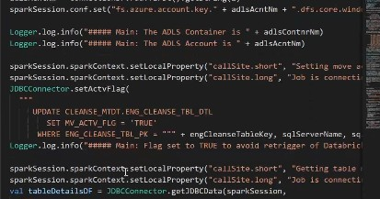

And once we are done with that

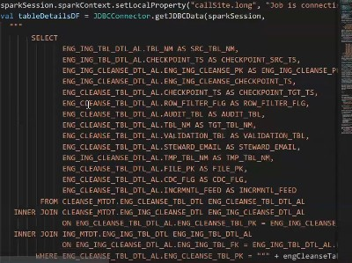

The above query compares the Ingestion Metadata and Cleanse Metadata and tries to get the information between both for a particular cleanse job and tries to get the below info

* Independent injection tables
* State of the checkpoints between those tables

